**Basic Concepts:**

In a single-processor system, only one process can run at a time. Others must wait until the CPU is free and can be rescheduled. The objective of multiprogramming is to have some process running at all times, to maximize CPU utilization. The idea is relatively simple. A process is executed until it must wait, typically for the completion of some I/O request. In a simple computer system, the CPU then just sits idle. All this waiting time is wasted; no useful work is accomplished. With multiprogramming, we try to use this time productively. Several processes are kept in memory at one time. When one process has to wait, the operating system takes the CPU away from that process and gives the CPU to another process. This pattern continues. Every time one process has to wait, another process can take over use of the CPU.

Scheduling of this kind is a fundamental operating-system function. Almost all computer resources are scheduled before use. The CPU is, of course, one of the primary computer resources. Thus, its scheduling is central to operating-system design.

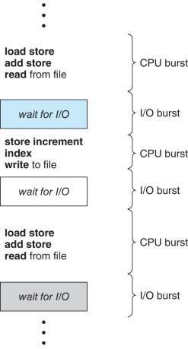

Figure 1.55 Alternating sequence of CPU and I/O bursts.

**CPU –I/O Burst Cycle**

The success of CPU scheduling depends on an observed property of processes: process execution consists of a cycle of CPU execution and I/O wait. Processes alternate between these two states. Process execution begins with a CPU burst. That is followed by an I/O burst, which is followed by another CPU burst, then another I/O burst, and so on. Eventually, the final CPU burst ends with a system request to terminate execution (Figure 1.55).

The durations of CPU bursts have been measured extensively. Although they vary greatly from process to process and from computer to computer, they tend to have a frequency curve similar to that shown in Figure 1.56. The curve is generally characterized as exponential or hyperexponential, with a large number of short CPU bursts and a small number of long CPU bursts.

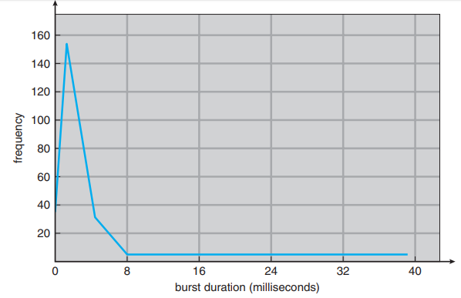

Figure 1.56 Histogram of CPU-burst durations.

An I/O-bound program typically has many short CPU bursts. A CPU-bound program might have a few long CPU bursts. This distribution can be important in the selection of an appropriate CPU-scheduling algorithm.

**CPU Scheduler**

Whenever the CPU becomes idle, the operating system must select one of the processes in the ready queue to be executed. The selection process is carried out by the short-term scheduler, or CPU scheduler. The scheduler selects a process from the processes in memory that are ready to execute and allocates the CPU to that process.

Note that the ready queue is not necessarily a first-in, first-out (FIFO) queue. As we shall see when we consider the various scheduling algorithms, a ready queue can be implemented as a FIFO queue, a priority queue, a tree, or simply an unordered linked list. Conceptually, however, all the processes in the ready queue are lined up waiting for a chance to run on the CPU. The records in the queues are generally process control blocks (PCBs) of the processes.

**Preemptive Scheduling**

CPU-scheduling decisions may take place under the following four circumstances:

1. When a process switches from the running state to the waiting state (for example, as the result of an I/O request or an invocation of wait() for the termination of a child process)
2. When a process switches from the running state to the ready state (for example, when an interrupt occurs)
3. When a process switches from the waiting state to the ready state (for example, at completion of I/O)
4. When a process terminates

For situations 1 and 4, there is no choice in terms of scheduling. A new process (if one exists in the ready queue) must be selected for execution. There is a choice, however, for situations 2 and 3.

When scheduling takes place only under circumstances 1 and 4, we say that the scheduling scheme is nonpreemptive or cooperative. Otherwise, it is preemptive. Under nonpreemptive scheduling, once the CPU has been allocated to a process, the process keeps the CPU until it releases the CPU either by terminating or by switching to the waiting state. This scheduling method was used by Microsoft Windows 3.x. Windows 95 introduced preemptive scheduling, and all subsequent versions of Windows operating systems have used preemptive scheduling. The Mac OS X operating system for the Macintosh also uses preemptive scheduling; previous versions of the Macintosh operating system relied on cooperative scheduling. Cooperative scheduling is the only method that can be used on certain hardware platforms, because it does not require the special hardware (for example, a timer) needed for preemptive scheduling.

Unfortunately, preemptive scheduling can result in race conditions when data are shared among several processes. Consider the case of two processes that share data. While one process is updating the data, it is preempted so that the second process can run. The second process then tries to read the data, which are in an inconsistent state.

Preemption also affects the design of the operating-system kernel. During the processing of a system call, the kernel may be busy with an activity on behalf of a process. Such activities may involve changing important kernel data (for instance, I/O queues). What happens if the process is preempted in the middle of these changes and the kernel (or the device driver) needs to read or modify the same structure? Chaos ensues. Certain operating systems, including most versions of UNIX, deal with this problem by waiting either for a system call to complete or for an I/O block to take place before doing a context switch. This scheme ensures that the kernel structure is simple, since the kernel will not preempt a process while the kernel data structures are in an inconsistent state. Unfortunately, this kernel-execution model is a poor one for supporting real-time computing where tasks must complete execution within a given time frame.

Because interrupts can, by definition, occur at any time, and because they cannot always be ignored by the kernel, the sections of code affected by interrupts must be guarded from simultaneous use. The operating system needs to accept interrupts at almost all times. Otherwise, input might be lost or output overwritten. So that these sections of code are not accessed concurrently by several processes, they disable interrupts at entry and reenable interrupts at exit. It is important to note that sections of code that disable interrupts do not occur very often and typically contain few instructions.

**Dispatcher**

Another component involved in the CPU-scheduling function is the dispatcher. The dispatcher is the module that gives control of the CPU to the process selected by the short-term scheduler. This function involves the following:

• Switching context

• Switching to user mode

• Jumping to the proper location in the user program to restart that program

The dispatcher should be as fast as possible, since it is invoked during every process switch. The time it takes for the dispatcher to stop one process and start another running is known as the dispatch latency.

**Scheduling Criteria**

Different CPU-scheduling algorithms have different properties, and the choice of a particular algorithm may favor one class of processes over another. In choosing which algorithm to use in a particular situation, we must consider the properties of the various algorithms.

Many criteria have been suggested for comparing CPU-scheduling algorithms. Which characteristics are used for comparison can make a substantial difference in which algorithm is judged to be best. The criteria include the following:

• **CPU utilization.** We want to keep the CPU as busy as possible. Conceptually, CPU utilization can range from 0 to 100 percent. In a real system, it should range from 40 percent (for a lightly loaded system) to 90 percent (for a heavily loaded system).

• **Throughput**. If the CPU is busy executing processes, then work is being done. One measure of work is the number of processes that are completed per time unit, called throughput. For long processes, this rate may be one process per hour; for short transactions, it may be ten processes per second.

• **Turnaround time.** From the point of view of a particular process, the important criterion is how long it takes to execute that process. The interval from the time of submission of a process to the time of completion is the turnaround time. Turnaround time is the sum of the periods spent waiting to get into memory, waiting in the ready queue, executing on the CPU, and doing I/O.

• **Waiting time.** The CPU-scheduling algorithm does not affect the amount of time during which a process executes or does I/O. It affects only the amount of time that a process spends waiting in the ready queue. Waiting time is the sum of the periods spent waiting in the ready queue.

• **Response time**. In an interactive system, turnaround time may not be the best criterion. Often, a process can produce some output fairly early and can continue computing new results while previous results are being output to the user. Thus, another measure is the time from the submission of a request until the first response is produced. This measure, called response time, is the time it takes to start responding, not the time it takes to output the response. The turnaround time is generally limited by the speed of the output device.

It is desirable to maximize CPU utilization and throughput and to minimize turnaround time, waiting time, and response time. In most cases, we optimize the average measure. However, under some circumstances, we prefer to optimize the minimum or maximum values rather than the average. For example, to guarantee that all users get good service, we may want to minimize the maximum response time.

Investigators have suggested that, for interactive systems (such as desktop systems), it is more important to minimize the variance in the response time than to minimize the average response time. A system with reasonable and predictable response time may be considered more desirable than a system that is faster on the average but is highly variable. However, little work has been done on CPU-scheduling algorithms that minimize variance.

**Scheduling Algorithms**

CPU scheduling deals with the problem of deciding which of the processes in the ready queue is to be allocated the CPU. There are many different CPU-scheduling algorithms. In this section, we describe several of them.

1. **First-Come, First-Served Scheduling**

By far the simplest CPU-scheduling algorithm is the first-come, first-served (FCFS) scheduling algorithm. With this scheme, the process that requests the CPU first is allocated the CPU first. The implementation of the FCFS policy is easily managed with a FIFO queue. When a process enters the ready queue, its PCB is linked onto the tail of the queue. When the CPU is free, it is allocated to the process at the head of the queue. The running process is then removed from the queue. The code for FCFS scheduling is simple to write and understand.

On the negative side, the average waiting time under the FCFS policy is often quite long. Consider the following set of processes that arrive at time 0, with the length of the CPU burst given in milliseconds:

**Process Burst Time**

**P1 24**

**P2 3**

**P3 3**

If the processes arrive in the order P1, P2, P3, and are served in FCFS order, we get the result shown in the following Gantt chart, which is a bar chart that illustrates a particular schedule, including the start and finish times of each of the participating processes:



The waiting time is 0 milliseconds for process P1, 24 milliseconds for process P2, and 27 milliseconds for process P3. Thus, the average waiting time is (0 + 24 + 27)/3 = 17 milliseconds. If the processes arrive in the order P2, P3, P1, however, the results will be as shown in the following Gantt chart:



The average waiting time is now (6 + 0 + 3)/3 = 3 milliseconds. This reduction is substantial. Thus, the average waiting time under an FCFS policy is generally not minimal and may vary substantially if the processes’ CPU burst times vary greatly.

In addition, consider the performance of FCFS scheduling in a dynamic situation. Assume we have one CPU-bound process and many I/O-bound processes. As the processes flow around the system, the following scenario may result. The CPU-bound process will get and hold the CPU. During this time, all the other processes will finish their I/O and will move into the ready queue, waiting for the CPU. While the processes wait in the ready queue, the I/O devices are idle. Eventually, the CPU-bound process finishes its CPU burst and moves to an I/O device. All the I/O-bound processes, which have short CPU bursts, execute quickly and move back to the I/O queues. At this point, the CPU sits idle. The CPU-bound process will then move back to the ready queue and be allocated the CPU. Again, all the I/O processes end up waiting in the ready queue until the CPU-bound process is done. There is a convoy effect as all the other processes wait for the one big process to get off the CPU. This effect results in lower CPU and device utilization than might be possible if the shorter processes were allowed to go first.

Note also that the FCFS scheduling algorithm is nonpreemptive. Once the CPU has been allocated to a process, that process keeps the CPU until it releases the CPU, either by terminating or by requesting I/O. The FCFS algorithm is thus particularly troublesome for time-sharing systems, where it is important that each user get a share of the CPU at regular intervals.

1. **Shortest-Job-First Scheduling**

A different approach to CPU scheduling is the shortest-job-first(SJF) scheduling algorithm. This algorithm associates with each process the length of the process’s next CPU burst. When the CPU is available, it is assigned to the process that has the smallest next CPU burst. If the next CPU bursts of two processes are the same, FCFS scheduling is used to break the tie. Note that a more appropriate term for this scheduling method would be the shortest-nextCPU-burst algorithm, because scheduling depends on the length of the next CPU burst of a process, rather than its total length. We use the term SJF because most people and textbooks use this term to refer to this type of scheduling.

As an example of SJF scheduling, consider the following set of processes, with the length of the CPU burst given in milliseconds:

**Process Burst Time**

**P1 6**

**P2 8**

**P3 7**

**P4 3**

Using SJF scheduling, we would schedule these processes according to the following Gantt chart:



The waiting time is 3 milliseconds for process P1, 16 milliseconds for process P2, 9 milliseconds for process P3, and 0 milliseconds for process P4. Thus, the average waiting time is (3 + 16 + 9 + 0)/4 = 7 milliseconds. By comparison, if we were using the FCFS scheduling scheme, the average waiting time would be 10.25 milliseconds.

The SJF scheduling algorithm is provably optimal, in that it gives the minimum average waiting time for a given set of processes. Moving a short process before a long one decreases the waiting time of the short process more than it increases the waiting time of the long process. Consequently, the average waiting time decreases.

The real difficulty with the SJF algorithm is knowing the length of the next CPU request. For long-term (job) scheduling in a batch system, we can use the process time limit that a user specifies when he submits the job. In this situation, users are motivated to estimate the process time limit accurately, since a lower value may mean faster response but too low a value will cause a time-limit-exceeded error and require resubmission. SJF scheduling is used frequently in long-term scheduling.

Although the SJF algorithm is optimal, it cannot be implemented at the level of short-term CPU scheduling. With short-term scheduling, there is no way to know the length of the next CPU burst. One approach to this problem is to try to approximate SJF scheduling. We may not know the length of the next CPU burst, but we may be able to predict its value. We expect that the next CPU burst will be similar in length to the previous ones. By computing an approximation of the length of the next CPU burst, we can pick the process with the shortest predicted CPU burst.

The next CPU burst is generally predicted as an exponential average of the measured lengths of previous CPU bursts. We can define the exponential average with the following formula. Let,



Commonly, α set to ½.

Preemptive version called shortest-remaining-time-first.

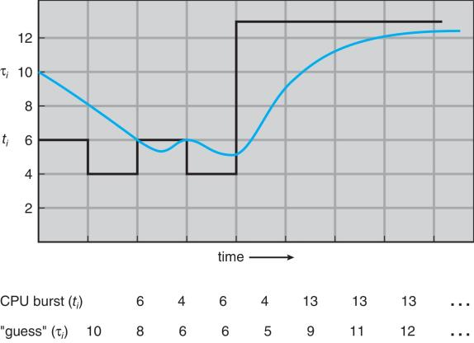

Figure 1.57 Prediction of the length of the next CPU burst.

* α =0
  + τn+1 = τn
  + Recent history does not count
* α =1
  + τn+1 = α *t*n
  + Only the actual last CPU burst counts
* If we expand the formula, we get:

τ*n*+1 = α t*n*+(1 *-* α*)*α *tn* -1+ …

*+(*1 - α *)j*α *tn* -*j* + …

*+(*1 - α *)n* +1 τ0

* Since both α and (1 - α) are less than or equal to 1, each successive term has less weight than its predecessor

The SJF algorithm can be either preemptive or nonpreemptive. The choice arises when a new process arrives at the ready queue while a previous process is still executing. The next CPU burst of the newly arrived process may be shorter than what is left of the currently executing process. A preemptive SJF algorithm will preempt the currently executing process, whereas a nonpreemptive SJF algorithm will allow the currently running process to finish its CPU burst. Preemptive SJF scheduling is sometimes called shortest-remaining-time-first scheduling.

As an example, consider the following four processes, with the length of the CPU burst given in milliseconds:

**Process Arrival Time Burst Time**

**P1 0 8**

**P2 1 4**

**P3 2 9**

**P4 3 5**

If the processes arrive at the ready queue at the times shown and need the indicated burst times, then the resulting preemptive SJF schedule is as depicted in the following Gantt chart:



Process P1 is started at time 0, since it is the only process in the queue. Process P2 arrives at time 1. The remaining time for process P1 (7 milliseconds) is larger than the time required by process P2 (4 milliseconds), so process P1 is preempted, and process P2 is scheduled. The average waiting time for this example is [(10 − 1) + (1 − 1) + (17 − 2) + (5 − 3)]/4 = 26/4 = 6.5 milliseconds. Nonpreemptive SJF scheduling would result in an average waiting time of 7.75 milliseconds.

1. **Round-Robin Scheduling**

The round-robin (RR) scheduling algorithm is designed especially for timesharing systems. It is similar to FCFS scheduling, but preemption is added to enable the system to switch between processes. A small unit of time, called a time quantum or time slice, is defined. A time quantum is generally from 10 to 100 milliseconds in length. The ready queue is treated as a circular queue. The CPU scheduler goes around the ready queue, allocating the CPU to each process for a time interval of up to 1 time quantum.

To implement RR scheduling, we again treat the ready queue as a FIFO queue of processes. New processes are added to the tail of the ready queue. The CPU scheduler picks the first process from the ready queue, sets a timer to interrupt after 1 time quantum, and dispatches the process.

One of two things will then happen. The process may have a CPU burst of less than 1 time quantum. In this case, the process itself will release the CPU voluntarily. The scheduler will then proceed to the next process in the ready queue. If the CPU burst of the currently running process is longer than 1 time quantum, the timer will go off and will cause an interrupt to the operating system. A context switch will be executed, and the process will be put at the tail of the ready queue. The CPU scheduler will then select the next process in the ready queue.

The average waiting time under the RR policy is often long. Consider the following set of processes that arrive at time 0, with the length of the CPU burst given in milliseconds:

Process Burst Time

P1 24

P2 3

P3 3

If we use a time quantum of 4 milliseconds, then process P1 gets the first 4 milliseconds. Since it requires another 20 milliseconds, it is preempted after the first time quantum, and the CPU is given to the next process in the queue, process P2. Process P2 does not need 4 milliseconds, so it quits before its time quantum expires. The CPU is then given to the next process, process P3. Once each process has received 1 time quantum, the CPU is returned to process P1 for an additional time quantum. The resulting RR schedule is as follows:



Let’s calculate the average waiting time for this schedule. P1 waits for 6 milliseconds (10 - 4), P2 waits for 4 milliseconds, and P3 waits for 7 milliseconds. Thus, the average waiting time is 17/3 = 5.66 milliseconds.

In the RR scheduling algorithm, no process is allocated the CPU for more than 1 time quantum in a row (unless it is the only runnable process). If a process’s CPU burst exceeds 1 time quantum, that process is preempted and is put back in the ready queue. The RR scheduling algorithm is thus preemptive.

If there are n processes in the ready queue and the time quantum is q, then each process gets 1/n of the CPU time in chunks of at most q time units. Each process must wait no longer than (n − 1) × q time units until its next time quantum. For example, with five processes and a time quantum of 20 milliseconds, each process will get up to 20 milliseconds every 100 milliseconds.

The performance of the RR algorithm depends heavily on the size of the time quantum. At one extreme, if the time quantum is extremely large, the RR policy is the same as the FCFS policy. In contrast, if the time quantum is extremely small (say, 1 millisecond), the RR approach can result in a large number of context switches. Assume, for example, that we have only one process of 10 time units. If the quantum is 12 time units, the process finishes in less than 1 time quantum, with no overhead. If the quantum is 6 time units, however, the process requires 2 quanta, resulting in a context switch. If the time quantum is 1 time unit, then nine context switches will occur, slowing the execution of the process accordingly (Figure 1.58).

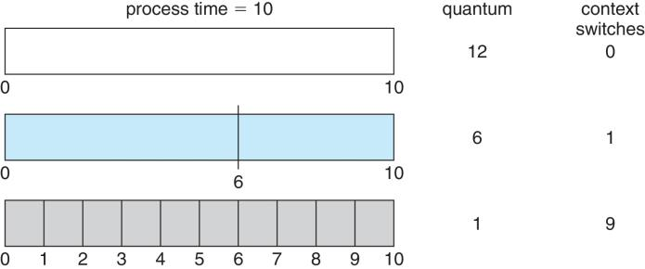

Figure 1.58 How a smaller time quantum increases context switches.

Thus, we want the time quantum to be large with respect to the contextswitch time. If the context-switch time is approximately 10 percent of the time quantum, then about 10 percent of the CPU time will be spent in context switching. In practice, most modern systems have time quanta ranging from 10 to 100 milliseconds. The time required for a context switch is typically less than 10 microseconds; thus, the context-switch time is a small fraction of the time quantum.

Turnaround time also depends on the size of the time quantum. As we can see from Figure 6.5, the average turnaround time of a set of processes does not necessarily improve as the time-quantum size increases. In general, the average turnaround time can be improved if most processes finish their next CPU burst in a single time quantum. For example, given three processes of 10 time units each and a quantum of 1 time unit, the average turnaround time is 29. If the time quantum is 10, however, the average turnaround time drops to 20. If context-switch time is added in, the average turnaround time increases even more for a smaller time quantum, since more context switches are required.

Although the time quantum should be large compared with the contextswitch time, it should not be too large. As we pointed out earlier, if the time quantum is too large, RR scheduling degenerates to an FCFS policy. A rule of thumb is that 80 percent of the CPU bursts should be shorter than the time quantum.

1. **Priority Scheduling**

The SJF algorithm is a special case of the general priority-scheduling algorithm. A priority is associated with each process, and the CPUis allocated to the process with the highest priority. Equal-priority processes are scheduled in FCFS order. An SJF algorithm is simply a priority algorithm where the priority (p) is the inverse of the (predicted) next CPU burst. The larger the CPU burst, the lower the priority, and vice versa.

Note that we discuss scheduling in terms of high priority and low priority. Priorities are generally indicated by some fixed range of numbers, such as 0 to 7 or 0 to 4,095. However, there is no general agreement on whether 0 is the highest or lowest priority. Some systems use low numbers to represent low priority; others use low numbers for high priority. This difference can lead to confusion. In this text, we assume that low numbers represent high priority.

As an example, consider the following set of processes, assumed to have arrived at time 0 in the order P1, P2, ···, P5, with the length of the CPU burst given in milliseconds:

**Process Burst Time Priority**

**P1 10 3**

**P2 1 1**

**P3 2 4**

**P4 1 5**

**P5 5 2**

Using priority scheduling, we would schedule these processes according to the following Gantt chart:

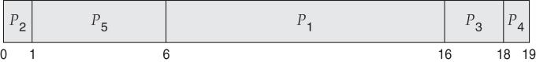

The average waiting time is 8.2 milliseconds

Priorities can be defined either internally or externally. Internally defined priorities use some measurable quantity or quantities to compute the priority of a process. For example, time limits, memory requirements, the number of open files, and the ratio of average I/O burst to average CPU burst have been used in computing priorities. External priorities are set by criteria outside the operating system, such as the importance of the process, the type and amount of funds being paid for computer use, the department sponsoring the work, and other, often political, factors.

Priority scheduling can be either preemptive or nonpreemptive. When a process arrives at the ready queue, its priority is compared with the priority of the currently running process. A preemptive priority scheduling algorithm will preempt the CPU if the priority of the newly arrived process is higher than the priority of the currently running process. A nonpreemptive priority scheduling algorithm will simply put the new process at the head of the ready queue.

A major problem with priority scheduling algorithms is indefinite blocking, or starvation. A process that is ready to run but waiting for the CPU can be considered blocked. A priority scheduling algorithm can leave some lowpriority processes waiting indefinitely. In a heavily loaded computer system, a steady stream of higher-priority processes can prevent a low-priority process from ever getting the CPU. Generally, one of two things will happen. Either the process will eventually be run (at 2 A.M. Sunday, when the system is finally lightly loaded), or the computer system will eventually crash and lose all unfinished low-priority processes. (Rumor has it that when they shut down the IBM 7094 at MIT in 1973, they found a low-priority process that had been submitted in 1967 and had not yet been run.)

A solution to the problem of indefinite blockage of low-priority processes is aging. Aging involves gradually increasing the priority of processes that wait in the system for a long time. For example, if priorities range from 127 (low) to 0 (high), we could increase the priority of a waiting process by 1 every 15 minutes. Eventually, even a process with an initial priority of 127 would have the highest priority in the system and would be executed. In fact, it would take no more than 32 hours for a priority-127 process to age to a priority-0 process.